# Use cases specification template

< ToDo: Create a table for each use case />

|  |  |  |
| --- | --- | --- |
| **Use case Id:** UC001 | Prepare Work Visa | |
| **Brief Description** | The system finishes up the preparation of the Work Visa as long as some requirements are fulfilled. | |
| **Primary actors** | AccSys, Immigration Officer. | |
| **Trigger(s)** | AccSys generates an issueless financial report. | |
| **Preconditions:**   1. Verification of job confirmation and police report was successful 2. Total number of work visas is less than limitation. 3. The financial report of the employer is without issues. 4. Immigration Officer’s Approval was successful. | | |
| **Post-conditions:**   1. A unique visa number is assigned and associated with employer data. 2. Total number of visas issued to the employer is incremented. | | |
| **Normal Scenario** | | |
| Actor Action | | System Response |
| 1. AccSys sends employer’s financial report | | 2. Checks the financial report (see 2.a.) |
|  | | 3. Assigns a unique visa number |
|  | | 4. Associates visa number with employer’s data |
|  | | 5. Includes <<Approve Visa>> (see 5.a.) |
|  | | 6. Increments total number of visas issued to the employer. |
|  | | 7. Notify Employer with application status |
| **Alternative flows:**  2.a. If the financial report has any issues, reject the application.  5.a. If visa not approved, reject the application. | | |

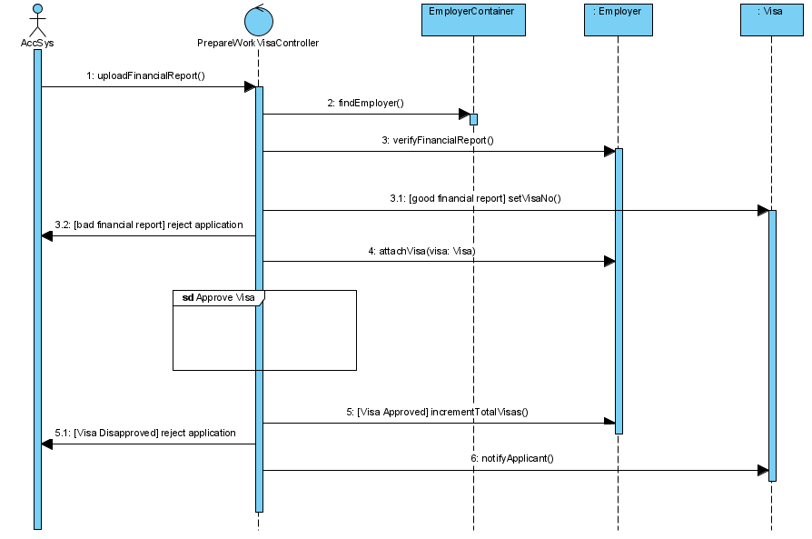

|  |  |  |
| --- | --- | --- |
| **Use case Id:** UC002 | Process Online Application Request (Tourist Visa) | |
| **Brief Description** |  | |
| **Primary actors** | Tourist | |
| **Trigger(s)** | Tourist request for an online application form | |
| **Preconditions:** | | |
| **Post-conditions:**   1. All information given by Tourist should be saved. | | |
| **Normal Scenario** | | |
| Actor Action | | System Response |
| 1. Tourist requests an online application form | | 2. Displays form |
| 3. Fills form & attaches copy of: photo, passport | | 4. Checks for missing info (see 4.a.) |
|  | | 5. Saves all information |
| **Alternative flows:**  4.a. If any info is missing, ask Tourist for missing info. | | |

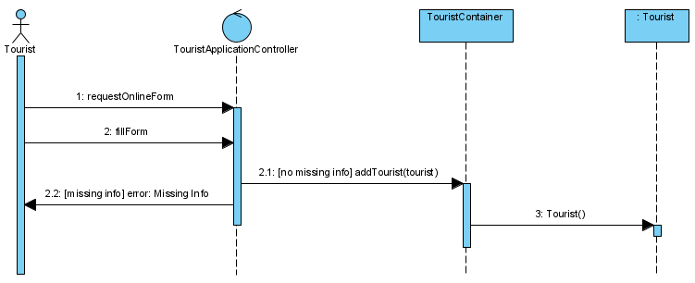

|  |  |  |
| --- | --- | --- |
| **Use case Id:** UC003 | Change Visa Status | |
| **Brief Description** | This use case begins once an applicant wants to cancel their visa. The system cancels applicant’s visa | |
| **Primary actors** | Applicant, AccSys | |
| **Trigger(s)** | Applicant requests cancellation | |
| **Preconditions: Applicant visa is valid/exists** | | |
| **Post-conditions: Visa is cancelled** | | |
| **Normal Scenario: Applicant’s visa is cancelled** | | |
| Actor Action | | System Response |
| 1. Applicant submits visa number | | 2. retrieve visa info |
|  | | 3. change visa status to “Cancelled” (See 3.a.) |
|  | | 4. update applicant info (See 4.a.) |
|  | | 5. inform AccSys about the cancellation |
|  | | 6. send cancellation to the applicant |
| **Alternative flows:**  3.a. For a work visa, request approval from immigration officer before status change (Extend UC02 Approve cancellation).  4.a. For a work visa, decrement the total number of visas allocated to the employee by one and update applicant info (Extend UC04 Update Number of Visas) | | |

|  |  |  |
| --- | --- | --- |
| **Use case Id:** UC004 | Prepare final report | |
| **Brief Description** | This use case begins when the staff requests a weekly overstays report. The system prepares a finalized report of overstays | |
| **Primary actors** | Staff, police system, immigration officer | |
| **Trigger(s)** | Staff requests overstays report | |
| **Preconditions: Report will only include expired visas** | | |
| **Post-conditions: final report is prepared** | | |
| **Normal Scenario: Weekly report is finalized** | | |
| Actor Action | | System Response |
|  | | 1. check for expired visas still in the country |
|  | | 2. make list of expired visas with associated passport and visa details |
|  | | 3. send visa list to police system |
| **4. Police system sends status report for visas** | | 5. update info based on the status report |
|  | | 6. Prepare the finalized report |
|  | | 7. Terminate (See 8.a.) |
| **Alternative flows:**  7.a. Send final report to Immigration officer if overstays exceed 50 | | |

|  |  |  |
| --- | --- | --- |
| **Use case Id:** UC005 | Approve Visa | |
| **Brief Description** | The system checks visa approval requirements, and sends approval or rejection to the Immigration officer | |
| **Primary actors** | AccSys, Immigration officer | |
| **Trigger(s)** | Approval is requested | |
| **Preconditions: Visa is valid/exists** | | |
| **Post-conditions: Visa is approved** | | |
| **Normal Scenario: Visa is approved** | | |
| Actor Action | | System Response |
|  | | 1. Ask AccSys to check payment (Tourist or employer) |
| **2. AccSys sends payment report** | | 3. Check payment report (See 3.a.) |
|  | | 4. Check if visa duration is correct (See 4.a.) |
|  | | 5. inform Immigration officer with approval |
| **Alternative flows:**  4.a. If there is an issue with the payment, inform Immigration officer with rejection  5.a. If there is an issue with the visa duration, inform Immigration officer with rejection | | |